Nikola Tesla (July 10, 1856 -Jan. 7th, 1943): 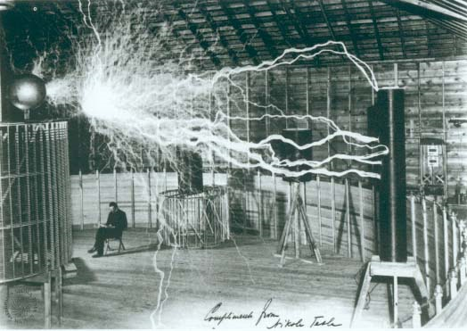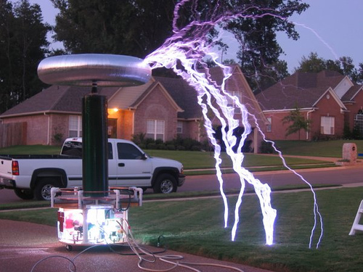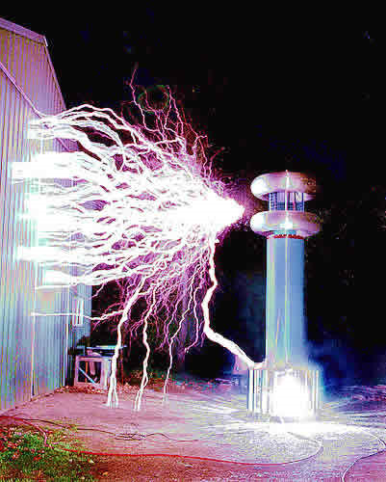
- Who is Nicola Tesla?
- What was Nicola Tesla’s life like before he became famous?
- What happened between Tesla and Thomas Edison?
- What significance does George Westinghouse have in Tesla’s life?
- What inventions and discoveries did Tesla come up with?
- What activity could we do reating to art?
- Where can we watch videos on Nicola Tesla and his Tesla Coil?
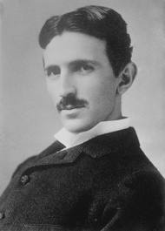
Nicola Tesla was the brilliant inventor and mastermind behind the way we use alternating current. He revolutionized the way we humans use electricity in our everyday lives. He discovered and invented a myriad of important devices and concepts during his lifetime. Many people believe he is more a genius than Thomas Edison and deserves more respect and recognition than he was given. “Tesla is the father of the radio and the modern electrical transmissions systems. He registered over 700 patents worldwide. His vision included exploration of solar energy and the power of the sea. He foresaw interplanetary communications and satellites(www.teslasociety.com).”
“Nicola Tesla was born on July 10, 1856 in Smiljan, Lika, which was then part of the Austro-Hungarian Empire, region of Croatia. Tesla studied at the Realschule, Karlstadt in 1873, the Polytechnic Institute in Graz, Austria and the University of Prague. He then became fascinated with electricity. He began his career as an electrical engineer with a telephone company in Budapest in 1881. Tesla was walking with a friend through the city park that the elusive solution to the rotating magnetic field flashed through his mind. With a stick, he drew a diagram in the sand explaining to his friend the principle of the induction motor. Before going to America, Tesla joined Continental Edison Company in Paris where he designed dynamos. While in Strassbourg in 1883, he privately built a prototype of the induction motor and ran it successfully. Unable to interest anyone in Europe in promoting this radical device, Tesla accepted an offer to work for Thomas Edison in New York. His childhood dream was to come to America to harness the power of Niagara Falls. After Tesla came to New York, he spent the next 59 years living there, and working in Edison’s lab in New Jersey(www.teslasociety.com).”
Tesla was concerned and upset because Edison had built tons of electrical plants all along the east coast that were powered by direct current. Tesla noticed how Edison’s direct current could only travel 2 miles before losing power. “Direct current flows continuously in one direction; alternating current changes direction 50 or 60 times per second and can be stepped up to vary high voltage levels, minimizing power loss across great distances. Tesla knew that future belonged to alternating current. He then developed a poly-phase alternating current system of generators, motors and transformers and held 40 basic U.S. patents on the system, which George Westinghouse bought, determined to supply America with the Tesla system. Edison did not want to lose his DC empire, and a bitter war ensued. This was the war of the currents between AC and DC. Tesla -Westinghouse ultimately emerged the victor because AC was a superior technology. It was a war won for the progress of both America and the world(www.teslasociety.com).”
One day in 1888, the inventor George Westinghouse came to Tesla’s lab to check out what he was doing. Tesla had improved his alternating current motors and Westinghouse was so impressed that he decided to become partners with him. This partnership changed the way America uses electricity. “Tesla’s A.C. induction motor is widely used throughout the world in industry and household appliances. It started the industrial revolution at the turn of the century. Electricity today is generated transmitted and converted to mechanical power by means of his inventions. Tesla’s greatest achievement is his poly-phase alternating current system, which is today lighting the entire globe(www.teslasociety.com).”
Tesla invented and discovered many things including “the rotating magnetic field, the fluorescent light , laser beam, wireless communications, wireless transmission of electrical energy, remote control, robotics, Tesla’s turbines and vertical take-off aircraft, as well as the Tesla Coil. He invented the Tesla coil in 1891, and is currently used very often in the radio and television business. The Tesla coil is one of Nikola Tesla's most famous inventions. It is essentially a high-frequency air-core transformer. It takes the output from a 120vAC to several kilovolt transformer & driver circuit and steps it up to an extremely high voltage. Voltages can get to be well above 1,000,000 volts and are discharged in the form of electrical arcs. Tesla himself got arcs up to 100,000,000 volts, but I don't think that has been duplicated by anybody else. Tesla coils are unique in the fact that they create extremely powerful electrical fields. Large coils have been known to wirelessly light up florescent lights up to 50 feet away, and because of the fact that it is an electric field that goes directly into the light and doesn't use the electrodes, even burned-out florescent lights will glow(www.teslasociety.com).”Tesla got to live out his dream of powering Niagara Falls. “He designed the first hydroelectric power-plant in Niagara Falls in 1895, which was the final victory of alternating current. The achievement was covered widely in the world press, and Tesla was praised as a hero world-wide(www.teslasociety.com).”
Now that we have learned about Nicola Tesla and his inventions, let’s do some research and look up some examples of his machines. Go on www.google.com to find examples of Tesla’s intricate machines, inventions and component parts. We are going to practice our observational skills by rendering from these references. Pretend your Tesla, and need to create a new machine to power your house and all your appliances. Print out three examples that have an interesting composition. Once you have done 3 small scale sketches, you may now create a larger scale rendering of one, or a combination of more than one intricate machine. This exercise will reiterate the concept of process, observational skills, and accentuate an appreciation for history and electricity.
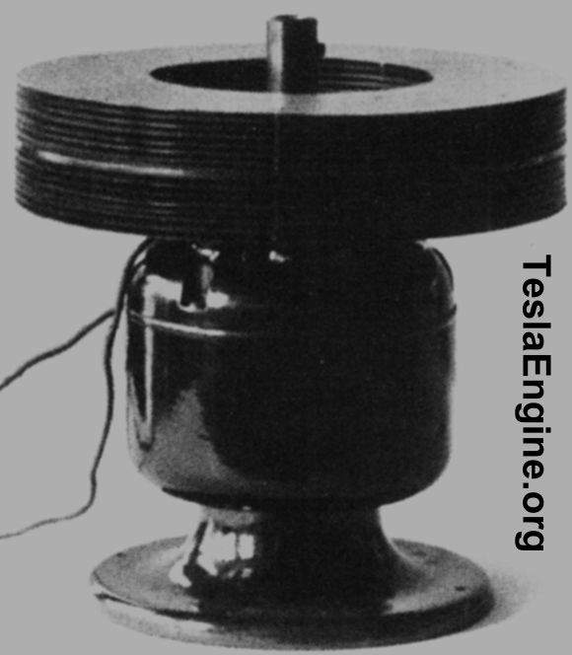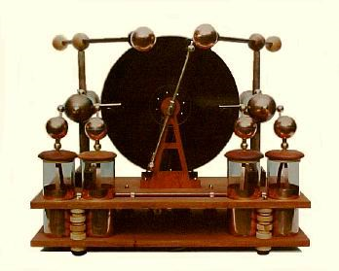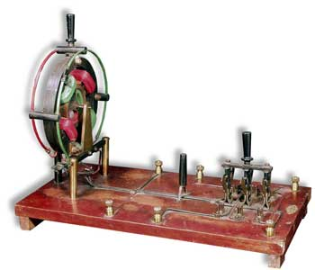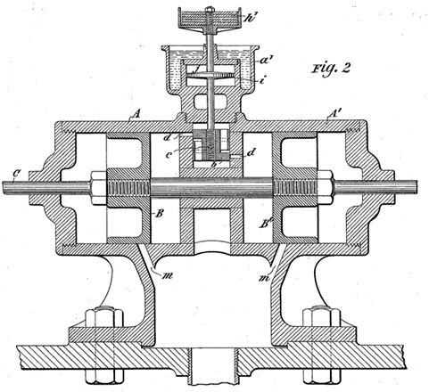

Great Videos about Nicola Tesla and the Tesla Coil:
http://www.youtube.com/watch?v=SlNGKly09CQ&feature=related
http://www.youtube.com/watch?v=FY-AS13fl30
http://www.youtube.com/watch?v=h5uiK_QnyrE

References:
Vujovic, L. (1998) Nikola Tesla: The Genius who lit the World ( Retrieved on February 25,2011 from http://www.teslasociety.com/biography.htm
Wikipedia, Nicola Tesla. Retrieved on February 25,2011 from http://en.wikipedia.org/wiki/Nikola_Tesla

