Leonardo Da Vinci
Leonardo Da Vinci was an incredible artist, inventor, scientist, botanist, writer, musician, and sculptor. He lived during the Italian Renaissance and has been deemed as one of the most ingenious and important artists within the history of art. His contributions to our modern day lives continue to baffle artists, educators, scientists and students. New information and new speculations always seem to be popping up about the mystique of the man and his works through new research, the internet and television programs. Incredible documentaries have been made about him, where scientists and engineers try to replicate his sketches and original designs. You will get the privilege to watch part 1-6 on Leonardo’s incredible life and inventions today. We will see how many of Leonardo’s inventions you can learn about today.

Step 1: Pick a partner.
Step 2: Go online and Watch: Leonardo Da Vinci Part 1-6 at :http://www.youtube.com/watch?v=IQ9ar3X_u1k make sure to read step 3!
Step 3: Fill out the following questions about Leonardo from the videos. You can type in your answers right on this page. Read two questions in advance to prepare you for the next questions.
Step 4: Go to http://www.leonardo-da-vinci-biography.com/leonardo-da-vinci-inventions.html and pick one out of the 4 categories of inventions created by Da Vinci. Be ready to summarize it, and source it later.
Step 5: TASK: You and your partner must create a PowerPoint presentation about the artist featuring his childhood, his adult life, interesting facts, his inventions, and your favorite short video clip from part1-6. You must also include one slide of one of Leonardo’s inventions that you and your partner think might not work if it was recreated. You must explain why you doubt its practicality. You must have at least 8 slides altogether.

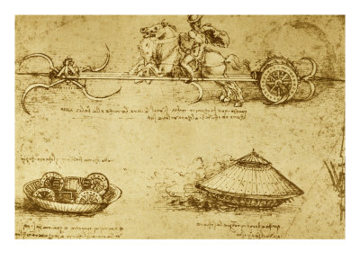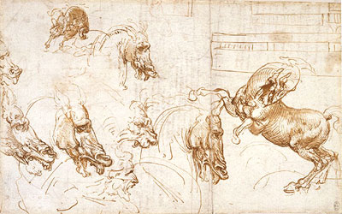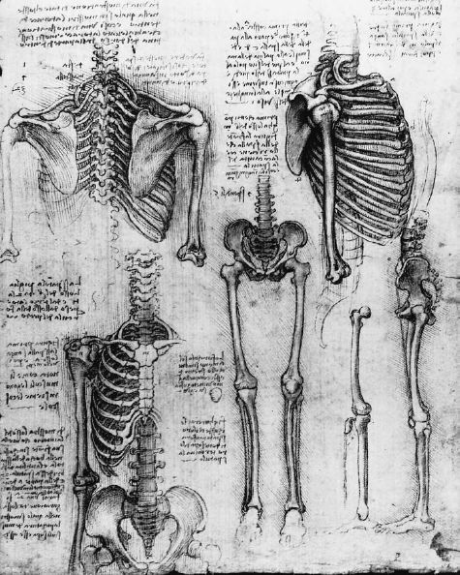

Go online and Watch: Leonardo Da Vinci Part 1 at :http://www.youtube.com/watch?v=IQ9ar3X_u1k
- What does da Vinci mean?
- Why couldn’t Leonardo learn Greek and Latin?
- In what interesting way did Leonardo write on paper?
- What part of nature was he most interested in, and why?
- How many pages of drawings and notes did Leonardo leave behind?
Click Leonardo Da Vinci: Part 2: http://www.youtube.com/watch?v=pp5435BYE3M
- What is the difference between Leonardo’s parachute and a modern day parachute?
- Where did Leonardo’s father move him to as a young boy?
- What art movement was going on during this time in Europe?
- Who did Leonardo get an apprenticeship with?
- What was the traditional paint to use back then?
- What type of paint did Leonardo decide to use instead?
Click Leonardo Da Vinci: Part 3: http://www.youtube.com/watch?v=WcCHmXhhA0s&NR=1
- What did Leonardo’s apprentice decide to do when he saw how beautiful Leonardo painted?
- Why might Leonardo be put to death?
- Where did Leonardo back up and move to?
- What types of things did Leonardo design, build and orchestrate for Ludovico Sforza?
Click Leonardo Da Vinci Part 4: http://www.youtube.com/watch?v=-lcz1sIAO1U&NR=1
- Who came along in Leonardo’s life who was his apprentice?
- What type of war machines did Leonardo design?
Click Leonardo Da Vinci: Part 5: http://www.youtube.com/watch?v=va-tNdVBtDc&NR=1
- Why did Leonardo’s tank replication not work? And why?
- What very famous and important commissioned painting did Leonardo start working on?
Click Leonardo da Vinci: Part 6:
- Why did the Last Supper painting start to decay?
- What happened to Leonardo’s giant clay model of the horse?
- Who came along to be Leonardo’s competitive enemy?

Now go to http://www.leonardo-da-vinci-biography.com/leonardo-da-vinci-inventions.html and pick one out of the 4 categories of inventions created by Da Vinci. Be ready to summarize it, and source it later.

TASK:

Now you and your partner must create a PowerPoint presentation about the artist featuring his childhood, his adult life, interesting facts, his inventions, and your favorite short video clip from part1-6. You must also include one slide of one of Leonardo’s inventions that you and your partner think might not work if it was recreated. You must explain why you doubt its practicality.

You must have at least 8 full slides in your PowerPoint presentation.

Process:
You and your partner must consider and include a variance of font styles, text sizes, text colors, and slide transitions within your PowerPoint to make it the most visually interesting and vibrant. Choose your images wisely. Choose your placement of your images and texts wisely. You do not want each slide to have a great deal of text. You want the viewer, or reader to be able to have rest for their eyes. You do not want to overwhelm the viewer with too much text, and or overlapping images. Each slide should include smooth transitions between each title, image, and text box. If you have any questions, you can just ask the teacher; but try your absolute best before you seek assistance.

You can use the following resources:

http://en.wikipedia.org/wiki/Leonardo_da_Vinci
http://www.mos.org/leonardo/
http://www.davincilife.com/
http://www.youtube.com/watch?v=HLB8cMqLg_k&feature=related
http://www.drawingsofleonardo.org/

Evaluation for PowerPoint Presentation:
Leonardo Da Vinci PowerPoint:

Name____________________________________________________________________________________________Grade (x4)______________________
Criteria | Inadequate  3 | Adequate  4 | Exceptional  5 | Grade
PowerPoint Requirements | Project incomplete. PowerPoint is missing more than 2 slide requirements. | Project almost complete.  Uses 7 full slides. Is missing one of the following slide requirements. | Project complete.  Incorporation of 8 full slides. Incorporation of his life, childhood, inventions, one favorite invention, one invention that you might have doubts about, interesting facts, and a favorite video clip.
Craftsmanship | Project finished but a little messy, with little attention to detail. Limited text variations, limited color variations, limited transitions. | Project finished but not the best possible work the student could have put in. Minimal text variations. | Project finished.  Carefully made, and beautifully crafted. Used different colored texts, and different sized texts. Used transitions.
Attitude  And  Responsibility | Student is on task but did the bare minimum to succeed. | Student worked enthusiastically and cleaned up properly. | Student worked diligently, enthusiastically, and helped others. Was not rude or distracting to others.
Effort | Project finish, but with minimal effort, no extra work put into the project. | Project finished but visually lacking organization, integrity and effort. | Project finished with maximum effort. Exceeds minimum limits.
